Appium Preparation

1. JDK
2. Android SDK
3. NodeJS
4. MSFT .NET Framework
5. Appium
6. Python or Java
7. JDK

Download and install latest JDK.

<http://www.oracle.com/technetwork/java/javase/downloads/index.html>

1. Select ***New*** In the ***System variables*.**

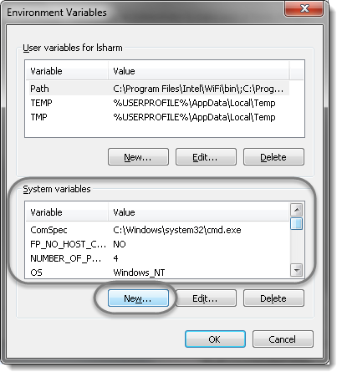

1. Define the *Variable name* as ‘***JAVA_HOME***‘ and *Variable value* as ‘***C:\Program Files\Java\jdk1.8.0_45****‘* (for this example JDK version 1.8.0 was installed in ‘*C:\Program Files\Java\jdk1.8.0_45*‘ folder; if needed, modify this value to reflect the real location).

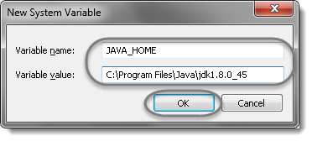

***Note****: Look at the previous chapter ‘Install the Java Development Kit’ to check the location of the JDK installation.*

1. Now we need to specify the location in the ***PATH***variable. For *PATH*, most probably it will already exists in your machine. So just select it and choose the ***Edit***option.

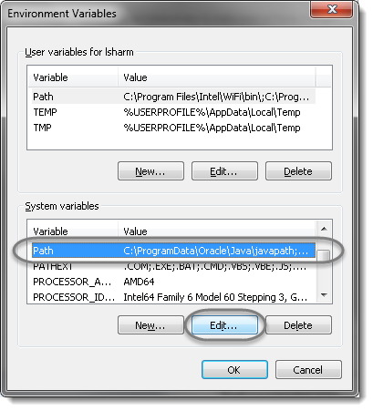

1. In the editor add the value ‘***;%JAVA_HOME%\bin***‘ or ‘***;C:Program Files\Java\jdk1.8.0_45\bin***‘.

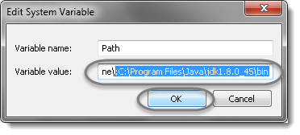

***Note****: The new values are separated by a semicolon from the existing ones and be carefull and do not make any changes in the existing string,*as it is a very sensitive information.

1. Now go to **Start** and type ***cmd***in the ***Run*** and hit ***Enter***. It will launch the Command Prompt. Type ‘***java -version***‘, it will display the following information.

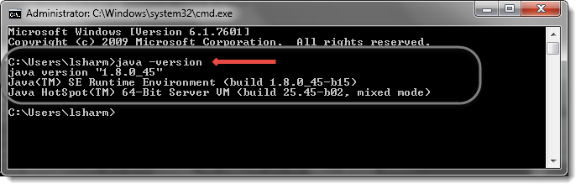

1. Android SDK

Install Android SDK, the tool you will use in the future are 1. ADB, 2. uiautomatorviewer

1. NodeJS

<https://nodejs.org/en/download/>

1. MSFT .NET Framework

<https://www.microsoft.com/en-in/download/details.aspx?id=30653>

1. Appium

<http://appium.io/downloads.html>

1. Download and install Python (above 3.6)

<https://www.python.org/downloads/>

add Python in your system variables.

1. Python related website:

<https://docs.python.org/3/library/unittest.html>

1. Appium Python binding:

<https://pypi.python.org/pypi/Appium-Python-Client>

Use python to execute the setup.py

For JAVA developer, please refer to below website:

<http://toolsqa.com/mobile-automation/appium/appium-tutorial/>

Here is the sample code for Appium, please refer to below:

<https://github.com/appium/sample-code/tree/master/sample-code/examples>